CSIT314 Software Development Methodologies - Group Project

Sprint 2 - US45: Search IDP categories
Interior Design Platform - Platform Manager
All diagrams were drawn in draw.io. Open "US45 Search IDP categories.drawio" in this folder to edit them - each diagram is its own page in that file. The exported images are in the "diagrams" folder.

Assumptions
- The system is the Interior Design Platform from the project specification. Sprint 2 covers the Interior Designer's log in / log out and company profile (US13 - US19) and the Platform Manager's log in / log out and IDP categories (US39 - US45).
- We follow B-C-E: the actor only talks to the boundary (page), the boundary only talks to the controller, and the controller works with the entity classes. There is one controller per use case.
- Following the lecturer's feedback (the same way as the other stories): the boundary checks all the input (required fields, lengths, formats, e.g. a category name is 3-50 characters) and trims spaces, then passes an entity object on. The controller just calls the entity and returns the result. The entity checks for duplicates and the database state (e.g. name already used, only Active categories are changed), then saves. Each B-C-E diagram has only one entity (a controller borrowed from another story doesn't count).
- Being logged in as a Platform Manager (UC39) is the precondition of these use cases, so the pages and the B-C-E / sequence diagrams don't check the manager again (no PlatformManagerLoginController). managerLoginRequired in app.py only sends someone with no session to /manager/login.
- The search page is also the IDP Categories list (/manager/categories): an empty search shows every category, the same way the User Profiles list is the US7 search page.
- The keyword is matched against the name and the description. The page trims spaces around the keyword and capitals don't matter.
- Suspended categories are included in the results, because the manager still needs to find them.
- Results are shown in the order the categories were created, with the name, description, status and a "View" link (US42).

1. User story
Story ID | US45
User story | As a platform manager, I want to search for IDP categories so that I can find the category I need to manage.
Actor | Platform Manager
Priority | Medium
Story points (estimate) | 2
Acceptance criteria | 1. The IDP Categories page has a search box and lists every category when nothing is searched.  2. Given I type a keyword and click "Search", then I see the categories whose name or description contains it (ignoring capitals), and the keyword stays in the box.  3. Given nothing matches, then I see "No IDP categories found".  4. Suspended categories are also found.  5. Given I click "Clear", then every category is shown again.
Tasks | T45.1 Write the use case description and draw the use case diagram  T45.2 Draw the B-C-E class diagram and the sequence diagram  T45.3 Draw the wireframes for the list, the search results and no results  T45.4 Write the unit tests first (TDD) for IDPCategory.searchIDPCategories(), the controller and the page  T45.5 Code IDPCategory.searchIDPCategories()  T45.6 Code SearchIDPCategoryController and SearchIDPCategoryPage  T45.7 Code the idpCategories.html template and the IDP Categories links (sidebar and dashboard)  T45.8 Run the test cases, fix bugs and push to the repo so the CI pipeline runs the unit tests

2. Use case diagram
The user story becomes one use case, UC45 Search IDP categories. The Platform Manager is the only actor.
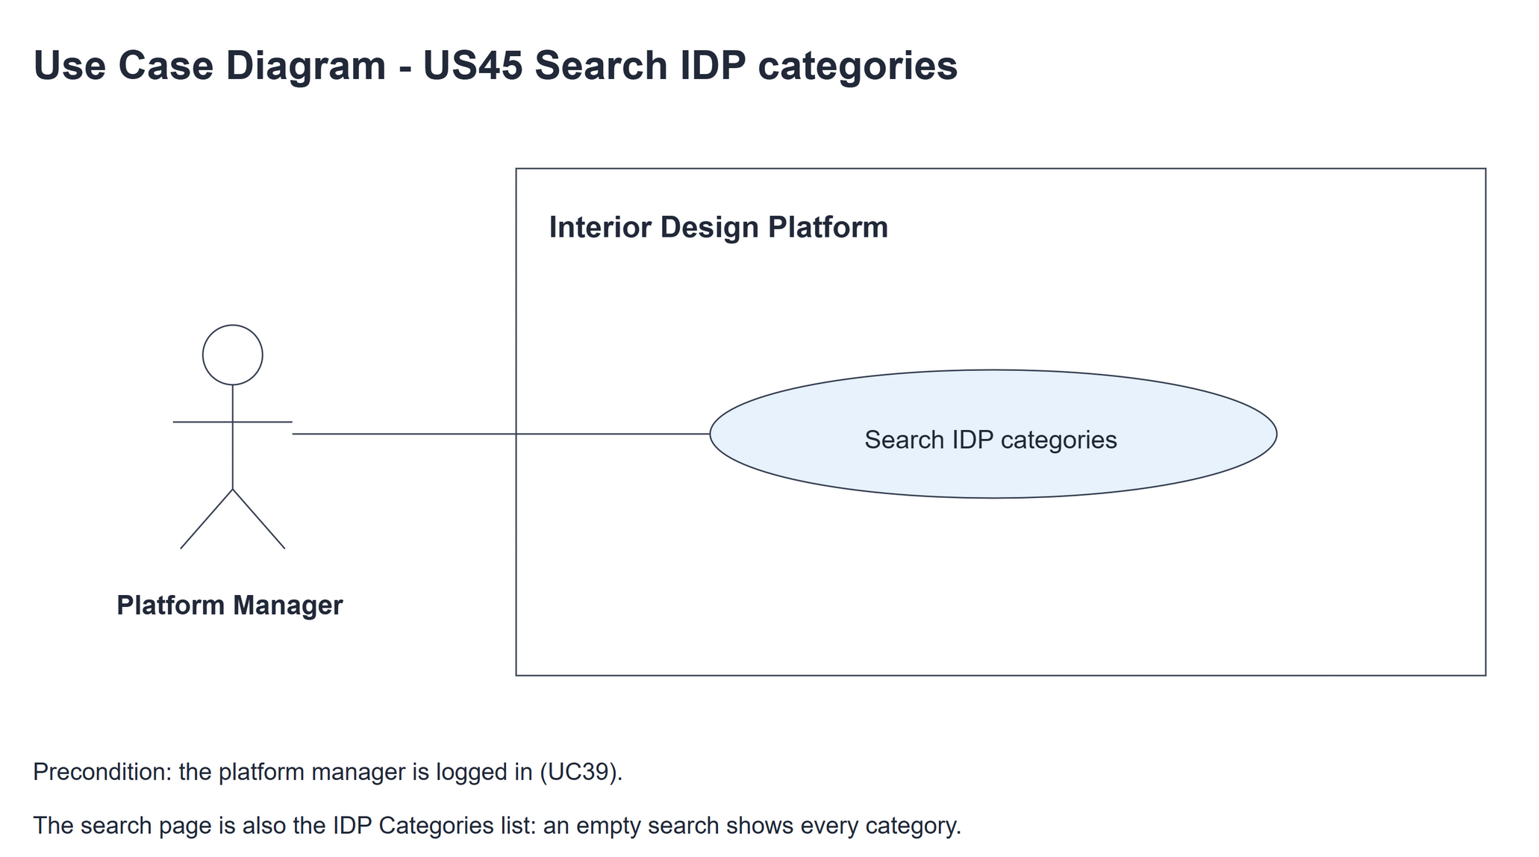
Figure 1: Use case diagram for US45 Search IDP categories

3. Use case description
Use case | UC45 Search IDP categories
Actor | Platform Manager
Brief description | The Platform Manager searches the IDP categories by keyword to find the one to manage.
User story | US45: As a platform manager, I want to search for IDP categories so that I can find the category I need to manage.
Preconditions | The Platform Manager is logged in (UC39).
Trigger | The Platform Manager types a keyword on the IDP Categories page and clicks "Search".
Basic flow | 1. The Platform Manager types a keyword and clicks "Search".  2. The system finds the categories whose name or description contains the keyword.  3. The system shows the matching categories with the keyword kept in the box.
Alternative flows | 1a. The keyword is empty (or the page is just opened): every category is shown.  2a. Nothing matches: the system shows "No IDP categories found". The manager can search again.
Postconditions | Nothing is changed (read only).

4. Wireframes
The wireframes were drawn in draw.io. They are low-fidelity: they show the layout and the flow, not the final colours. The orange numbers match the notes under each screen.

4a - All categories
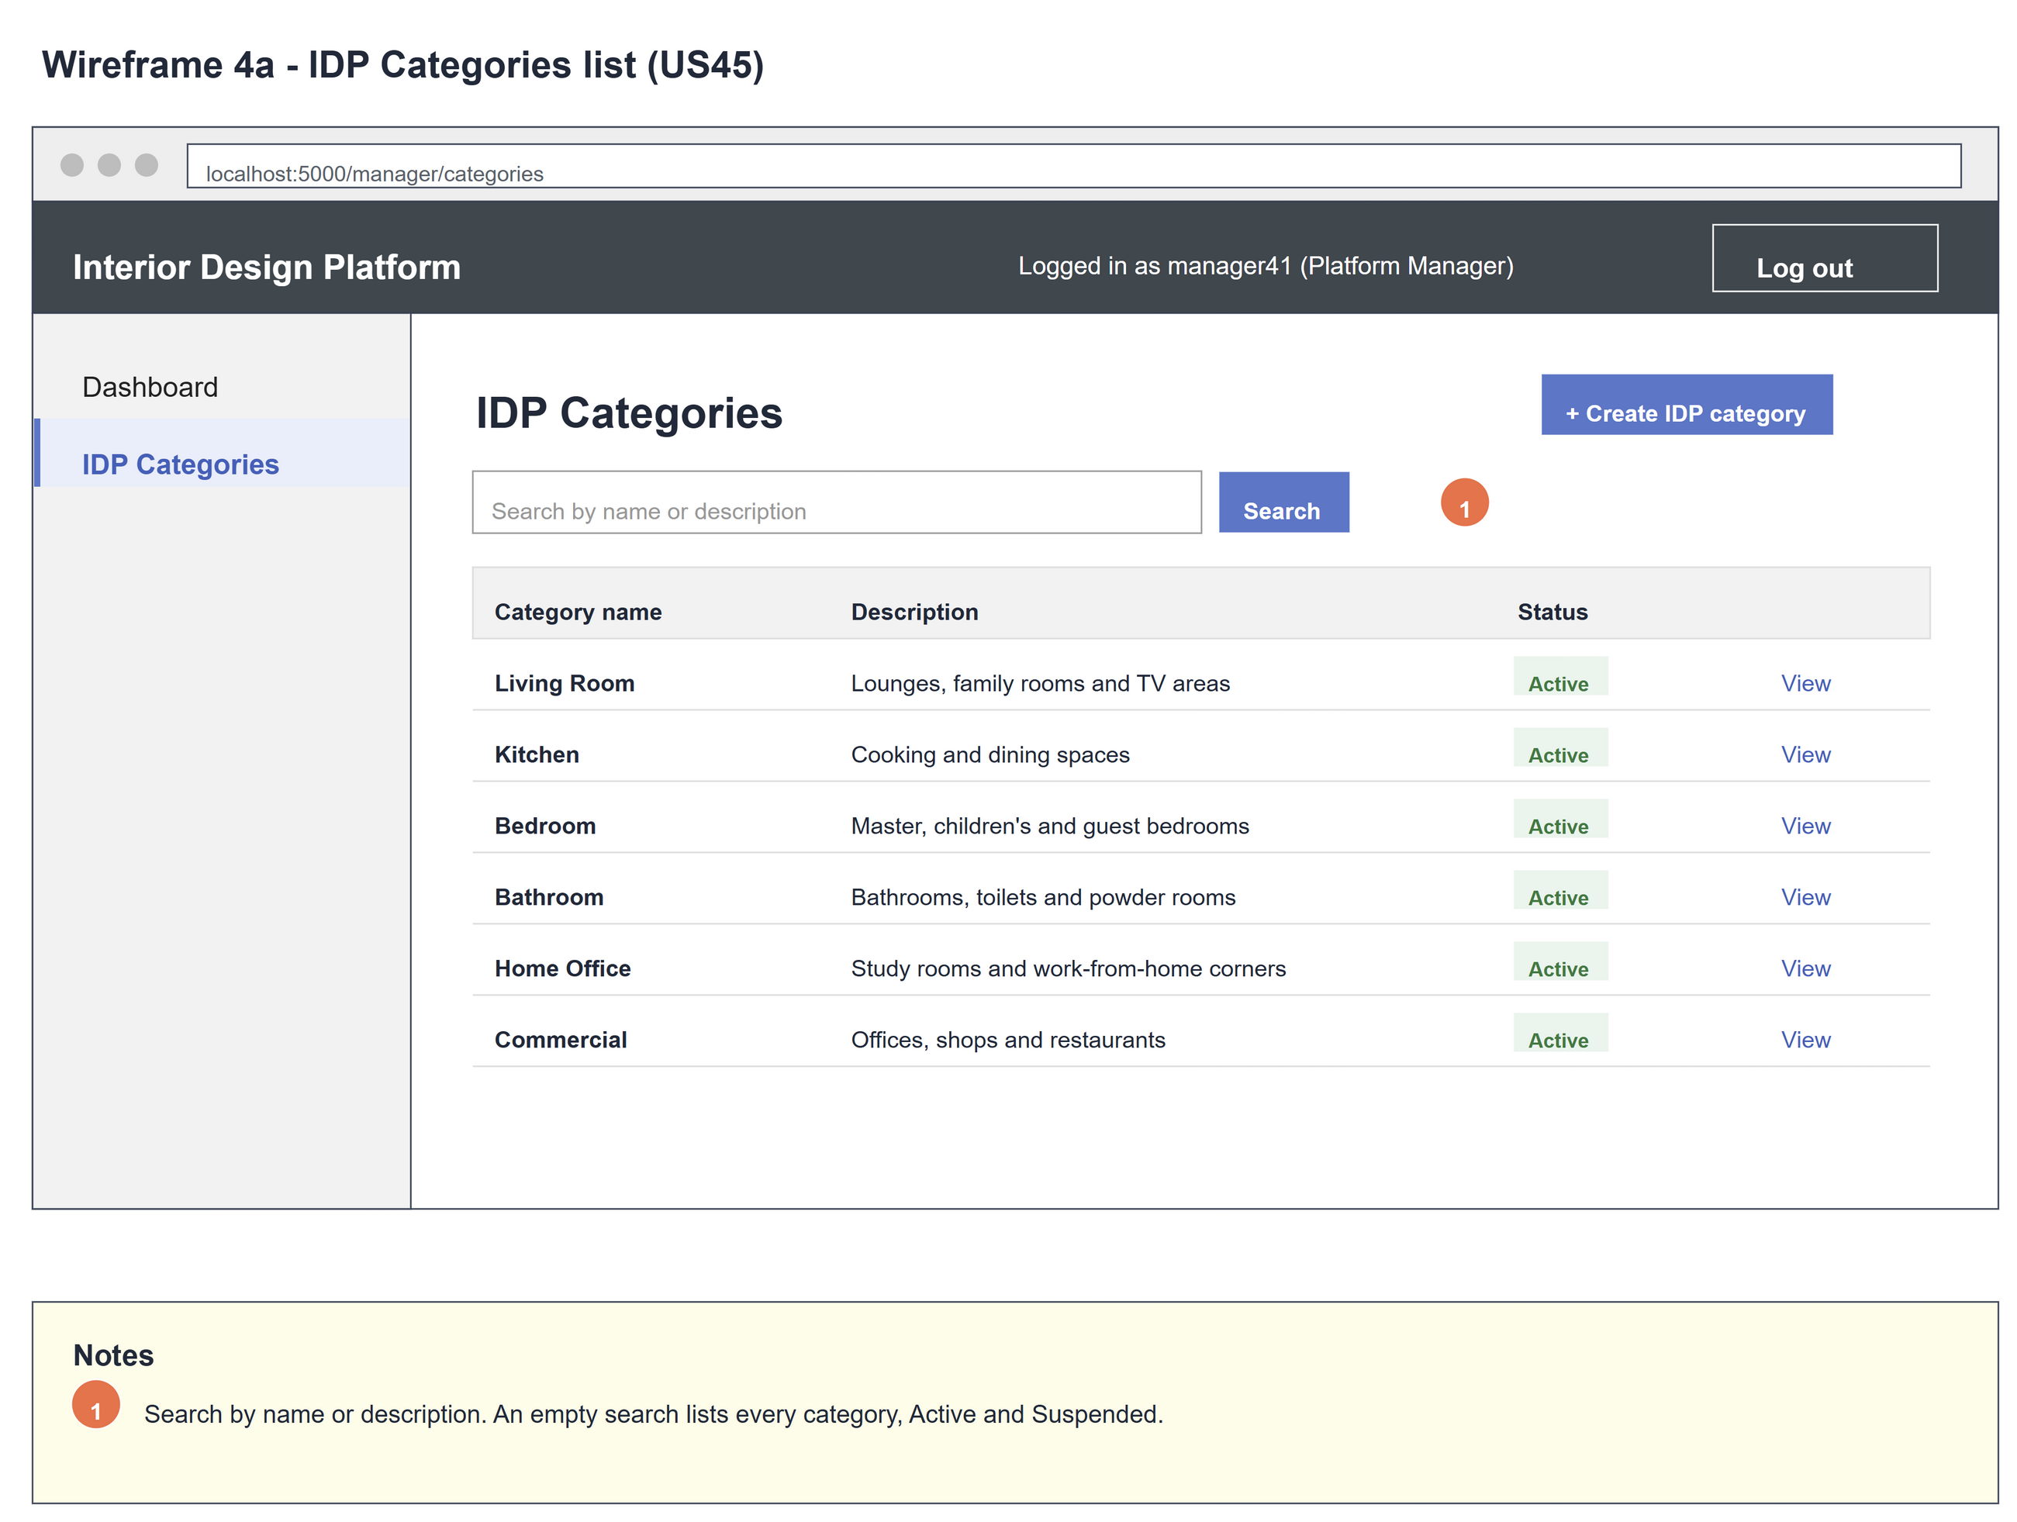
Figure 2: Wireframe 4a - All categories (US45)

4b - Search results
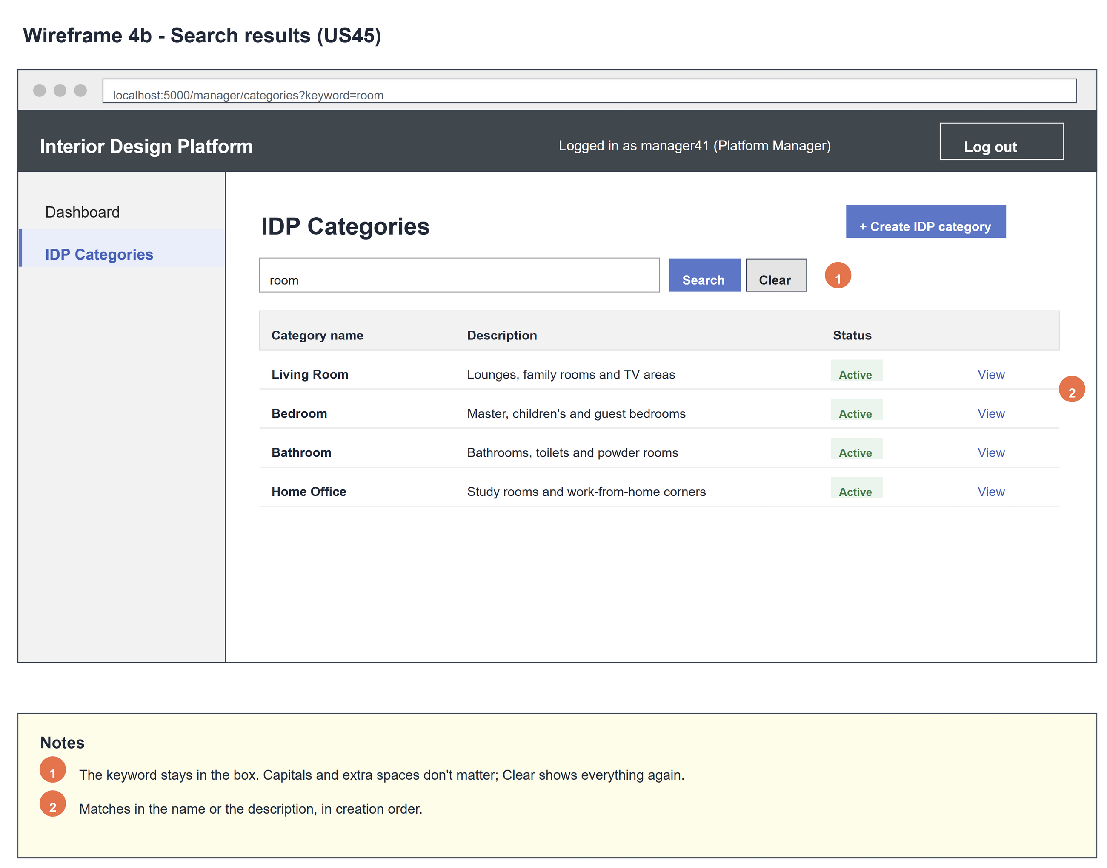
Figure 3: Wireframe 4b - Search results (US45)

4c - No results
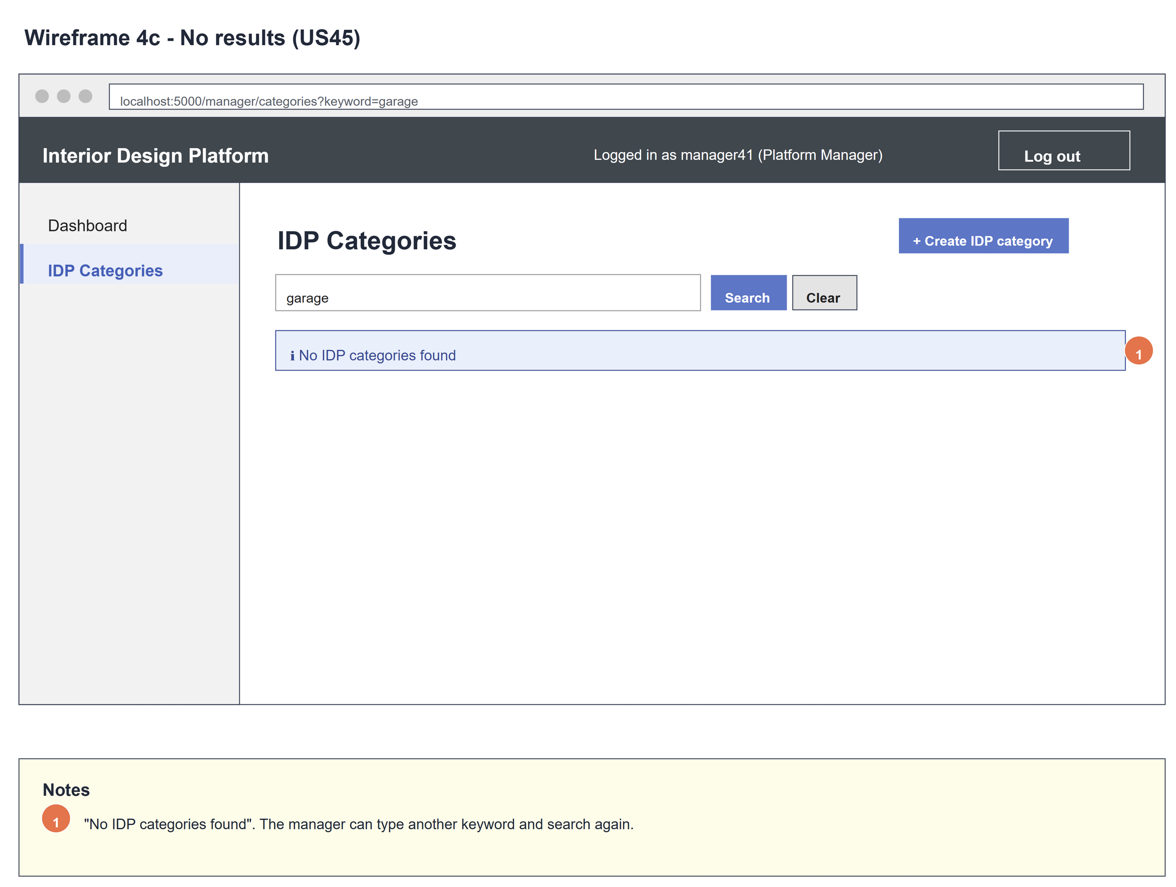
Figure 4: Wireframe 4c - No results (US45)

5. B-C-E class diagram
The solid line means the boundary calls the controller. The dashed lines mean the controller uses the other classes. Only the operations needed for this use case are shown, with the same names as the code.
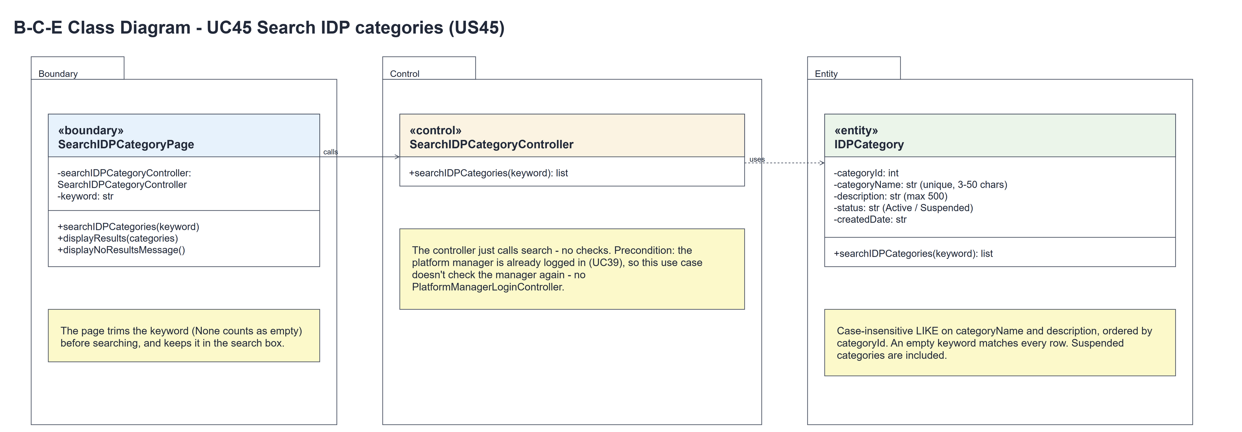
Figure 5: B-C-E class diagram for US45 Search IDP categories
Layer | Class | What it does
Boundary | SearchIDPCategoryPage | The IDP Categories list and search box. searchIDPCategories() trims the keyword (None counts as empty), asks the controller, then displayResults() or displayNoResultsMessage().
Control | SearchIDPCategoryController | Controller for UC45. searchIDPCategories() just calls the entity and returns the matching categories.
Entity | IDPCategory | searchIDPCategories() does a case-insensitive search of the name and description; an empty keyword matches everything.

6. Sequence diagram
The sequence diagram follows UC45. The page tidies the keyword, then the controller just asks IDPCategory for the matches. The alt shows the results, or "No IDP categories found".
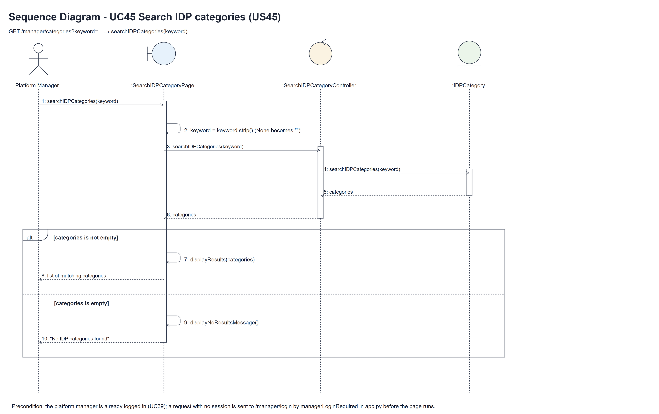
Figure 6: Sequence diagram for UC45 Search IDP categories

7. Test cases
Test data used below (same as database/seedData.py and the test files): user profiles User Admin (id 1), Interior Designer (id 2), Customer (id 3) and Platform Manager (id 4), all Active. User accounts admin01 / Admin@123 (User Admin) and cust001 / Cust@123 (Customer). The manager account manager45 / Manager@123 (Daniel Tan, Platform Manager profile) is made first with UC8. IDP categories: Kitchen ("Cooking and dining spaces"), Bedroom ("Calm sleeping spaces") and Office ("Work spaces with a kitchenette").

7a. System test cases (black box)
Equivalence partitioning and boundary value analysis were used to pick the test data. Fill in "Actual result" and "Pass/Fail" after running each test.
Test ID | Scenario | Prerequisites | Test steps | Test data | Expected result | Actual result | Pass / Fail
TC45.1 | List every category | Three categories exist. | 1. Click IDP Categories in the sidebar | - | Kitchen, Bedroom and Office are listed.
TC45.2 | Search by name | Three categories exist. | 1. Type the keyword  2. Click "Search" | Bedroom | Only Bedroom. The keyword stays in the box.
TC45.3 | Search by description | Three categories exist. | 1. Search | sleeping | Only Bedroom.
TC45.4 | Partial match in name and description | Three categories exist. | 1. Search | kitchen | Kitchen and Office (its description has "kitchenette").
TC45.5 | Capitals and spaces | Three categories exist. | 1. Search | " BEDROOM " | Only Bedroom.
TC45.6 | No results | Three categories exist. | 1. Search | garage | "No IDP categories found".
TC45.7 | Suspended categories are found | Bedroom is Suspended. | 1. Search | Bedroom | Bedroom with a Suspended badge.
TC45.8 | Not logged in | Not logged in. | 1. Open /manager/categories | - | The manager login page is shown.

7b. Unit test cases (for TDD)
These are written before the code (test-driven development) and run with pytest. They cover normal inputs, abnormal inputs and boundary values. Each one matches a test function in tests/test_us45_searchIDPCategories.py (UT45.n = test_ut45_n_...).
Test ID | Class and method | Input / setup | Expected output | Type | Pass / Fail
UT45.1 | IDPCategory.searchIDPCategories() | "Bedroom" | [Bedroom] | Normal | Pass
UT45.2 | IDPCategory.searchIDPCategories() | "sleeping" (description) | [Bedroom] | Normal | Pass
UT45.3 | IDPCategory.searchIDPCategories() | "BEDROOM" | [Bedroom] | Boundary | Pass
UT45.4 | IDPCategory.searchIDPCategories() | "kitchen" | [Kitchen, Office] | Normal | Pass
UT45.5 | IDPCategory.searchIDPCategories() | Empty keyword | All 3 in creation order | Boundary | Pass
UT45.6 | IDPCategory.searchIDPCategories() | Bedroom Suspended | Bedroom returned with status Suspended | Normal | Pass
UT45.7 | SearchIDPCategoryController.searchIDPCategories() | "Bedroom" | [Bedroom] | Normal | Pass
UT45.8 | SearchIDPCategoryController.searchIDPCategories() | Empty keyword | All 3 | Boundary | Pass
UT45.9 | SearchIDPCategoryController.searchIDPCategories() | "garage" | Empty list | Abnormal | Pass
UT45.14 | SearchIDPCategoryPage.searchIDPCategories() | " Bedroom " | keyword kept as "Bedroom" | Boundary | Pass
UT45.16 | SearchIDPCategoryPage.searchIDPCategories() | None | keyword kept as "" | Abnormal | Pass
UT45.10 | SearchIDPCategoryPage.searchIDPCategories() | GET /manager/categories | All 3 listed | Normal | Pass
UT45.11 | SearchIDPCategoryPage.displayResults() | ?keyword=sleeping | Bedroom only. Keyword kept in the box | Normal | Pass
UT45.12 | SearchIDPCategoryPage.displayNoResultsMessage() | ?keyword=garage | "No IDP categories found" | Abnormal | Pass
UT45.13 | /manager/categories (managerLoginRequired) | Not logged in | Redirects to /manager/login | Abnormal | Pass
UT45.15 | Manager dashboard | manager45 opens the dashboard | Links to /manager/categories | Normal | Pass

